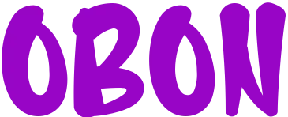



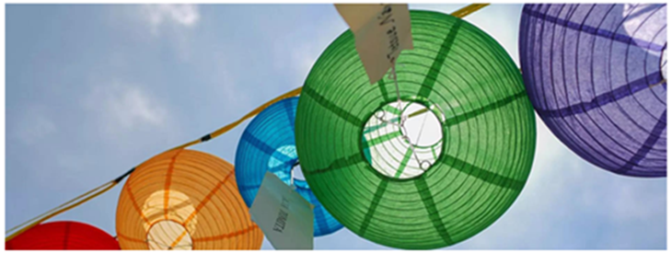

**Sunday, July 16 @ 12 Noon**

** •  •**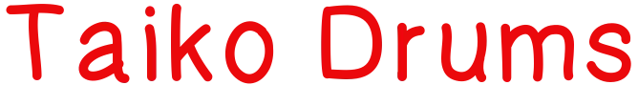

KaoriGel Bold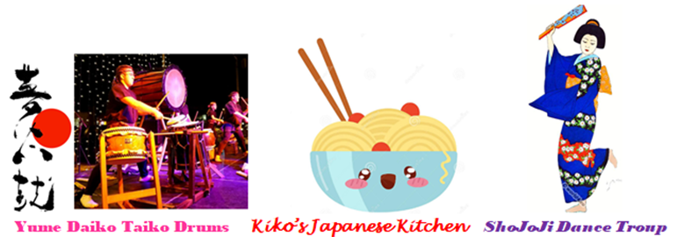

**21600 Shaker Blvd. Shaker Hts.**

**Shaker Blvd. at S. Belvoir**

(Cleveland Buddhist Temple - on grounds of the Unitarian Universalist Congregation of Cleveland)

**FREE & OPEN TO ALL**

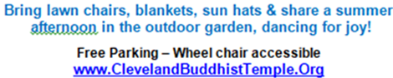 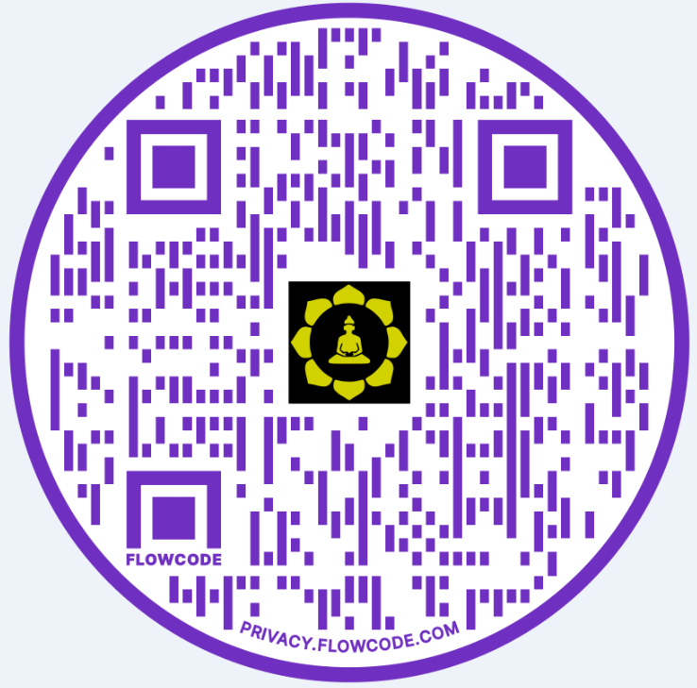

KaoriGel Bold